./

GENESIS - Learning Outcome & Mini-project Summary Report



|  |  |  |  |  |  |
| --- | --- | --- | --- | --- | --- |
| **Ver. Rel. No.** | **Release Date** | **Prepared. By** | **Reviewed By** | **To be Approved** | **Remarks/Revision Details** |
| 1 | 04-12-2020 | Akshay Sai Reddy G |  |  |  |
|  |  |  |  |  |  |
|  |  |  |  |  |  |
|  |  |  |  |  |  |
|  |  |  |  |  |  |

**Details**

**Contents**

**MINIPROJECT 4**

**Problem Statement 5**

**Requirements 5**

**WWWWH 5**

**SWOT Analysis 6**

**Design 6**

**Test Plan 7**

**Git Link 7**

**Git Dashboard 8**

**MINI PROJECT**

**Title:**

**MOBILE PHONE GUIDE**

**Submission by: Akshay Sai Reddy G**

**Candidate ID: 105396**

**Problem Statement**:

This Project can help users to buy suitable Mobile Phone for their needs. Based on the user’s requirements and price range, Mobile Phone(s) is/are suggested. And users are also allowed to view full details and features of a particular Mobile.

**Requirements**:

* Compiler - MinGW for C programming
* Software - Codeblocks or Dev C++
* Operating System – Windows or any Linux based distribution
* Compiler – GCC

**WWWWH:**

**What-** This Project can help users to buy suitable Mobile Phone for their needs. Based on the user’s requirements and price range, Mobile Phone(s) is/are suggested. And users are also allowed to view full details and features of a particular Mobile.

**WHY-** Mobile Phone companies release too many mobile phone models into the market to occupy more market share. This is a serious problem and confusion created among users. People get confused which Mobile Phone to buy. Companies keep launching devices with few minor upgrades or gimmicky features creating lots of hype around them. So, this Project helps users in buying a good Mobile Phone based on their requirements.

**Where-** It can be useful from anywhere within India.

**When-** This Project can be when the user is facing difficulty in choosing the right Mobile Phone for them.

**How-** Full detailed specifications of Mobiles are made available. User can choose to vie

w them by a model or all together. Admin can add new Mobile details from time to time.

**SWOT Analysis:**

**Strengths-**

* Ease of use
* Detailed Specification list

**Weakness-**

* Doesn’t specify to buy a particular Mobile.

**Opportunities-**

* Helps when user is in confusion to buy which Mobile Phone

**Design:**

**Structural-**

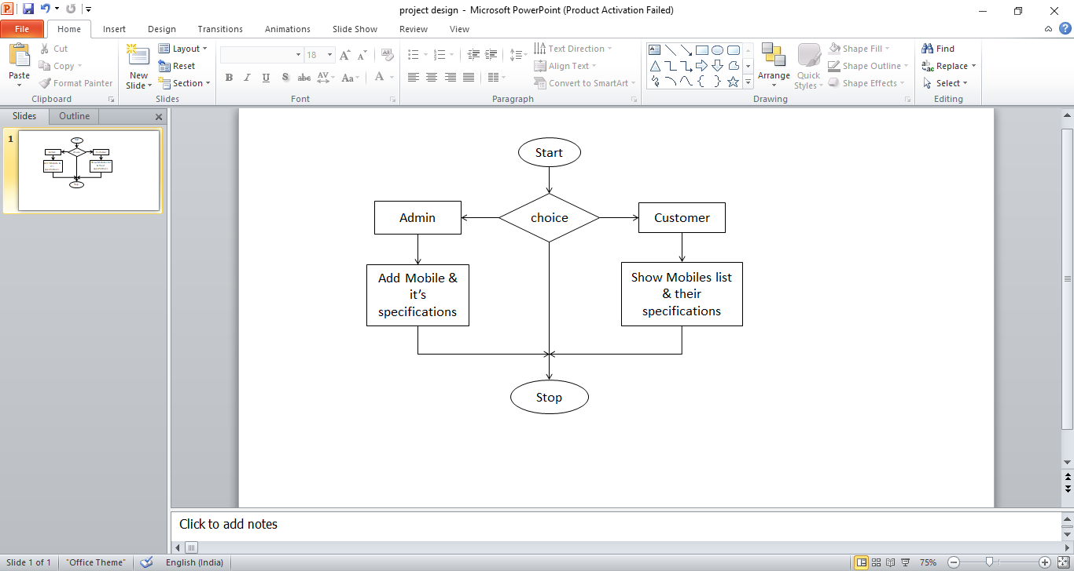

**Behavioral-**

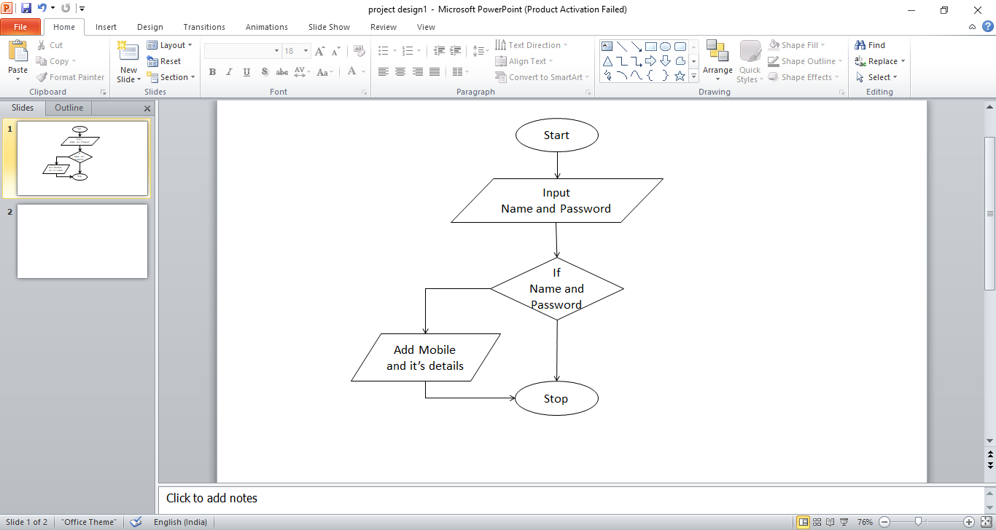

**Test Plan:**

1. To check if the program displays all the options correctly to the user
2. To check if the admin is able to login correctly.
3. To check if admin is able to add data correctly.
4. To check if user input is read correctly.
5. To check if list of Mobiles is shown properly.
6. To check if the specification are shown correctly
7. To check appropriate information /details are provided, so that user doesn’t get confused.

**Git Link:**

<https://github.com/99003183/MobilePhoneGuide>

**Git Dashboard:**

### 